SendGrid now requires extra info to create a Single Sender.

Following the next steps, you will get quick access to your API key.

1. Fill out the fields there with help from trash-mail.com

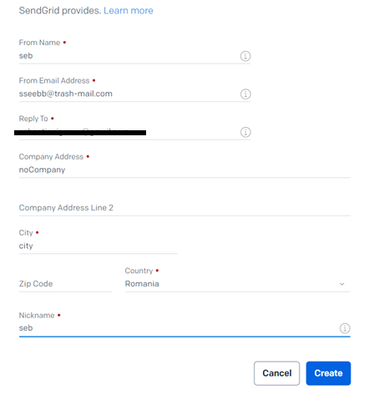

Where is the “Reply to” just insert your regular e-mail address, like [seb@gmail.com](mailto:seb@gmail.com)

1. Enter trash-mail.com/inbox/ and login into your fake e-mail address

1. Open the mail and verify your account

1. You will be sent to sendgrid.com and that’s it!

1. You can now go and setup your API Key, by going to Email API -> Integration Guide

And proceed as in course. (when checking mails sent from @trash-mail.com, check Spam too)

